Event Handling
Overview
This chapter examines an important aspect of Java that relates to applets: events. As explained in Chapter 19, applets are event-driven programs. Thus, event handling is at the core of successful applet programming. Most events to which your applet will respond are generated by the user. These events are passed to your applet in a variety of ways, with the specific method depending upon the actual event. There are several types of events. The most commonly handled events are those generated by the mouse, the keyboard, and various controls, such as a push button. Events are supported by the java.awt.event package.
The Delegation Event Model
The modern approach to handling events is based on the delegation event model, which defines standard and consistent mechanisms to generate and process events. Its concept is quite simple: a source generates an event and sends it to one or more listeners; the listener simply waits until it receives an event. Once received, the listener processes the event and then returns. The advantage of this design is that the application logic that processes events is cleanly separated from the user interface logic that generates those events. A user interface element is able to "delegate" the processing of an event to a separate piece of code. In the delegation event model, listeners must register with a source in order to receive an event notification. This provides an important benefit: notifications are sent only to listeners that want to receive them.
Events
In the delegation model, an event is an object that describes a state change in a source. It can be generated as a consequence of a person interacting with the elements in a graphical user interface. Some of the activities that cause events to be generated are pressing a button, entering a character via the keyboard, selecting an item in a list, and clicking the mouse. Many other user operations could also be cited as examples. Events may also occur that are not directly caused by interactions with a user interface. For example, an event may be generated when a timer expires, a counter exceeds a value, software or hardware failure occurs, or an operation is completed. You are free to define events that are appropriate for your application.
Event Sources
A source is an object that generates an event. This occurs when the internal state of that object changes in some way. Sources may generate more than one type of event. A source must register listeners in order for the listeners to receive notifications about a specific type of event. Each type of event has its own registration method. Here is the general form:

public void addTypeListener(TypeListener el)

Here, Type is the name of the event and el is a reference to the event listener. For example, the method that registers a keyboard event listener is called addKeyListener( ). The method that registers a mouse motion listener is called addMouseMotionListener( ). When an event occurs, all registered listeners are notified and receive a copy of the event object. This is known as multicasting the event. In all cases, notifications are sent only to listeners that register to receive them. Some sources may allow only one listener to register. The general form of such a method is this:

public void addTypeListener(TypeListener el)throws java.util.TooManyListenersException

Here, Type is the name of the event and el is a reference to the event listener. When such an event occurs, the registered listener is notified. This is known as unicasting the event. A source must also provide a method that allows a listener to unregister an interest in a specific type of event. The general form of such a method is this:

public void removeTypeListener(TypeListener el)

Here, Type is the name of the event and el is a reference to the event listener. For example, to remove a keyboard listener, you would call removeKeyListener( ). The methods that add or remove listeners are provided by the source that generates events. For example, the Component class provides methods to add and remove keyboard and mouse event listeners.
Event Listeners
A listener is an object that is notified when an event occurs. It has two major requirements. First, it must have been registered with one or more sources to receive notifications about specific types of events. Second, it must implement methods to receive and process these notifications. The methods that receive and process events are defined in a set of interfaces found in java.awt.event. For example, the MouseMotionListener interface defines two methods to receive notifications when the mouse is dragged or moved. Any object may receive and process one or both of these events if it provides an implementation of this interface
Event Classes
The classes that represent events are at the core of Java's event handling mechanism. Thus, we begin our study of event handling with a tour of the event classes. As you will see, they provide a consistent, easy-to-use means of encapsulating events.At the root of the Java event class hierarchy is EventObject, which is in java.util. It is the superclass for all events. Its one constructor is shown here:

EventObject(Object src)

Here, src is the object that generates this event. EventObject contains two methods: getSource( ) and toString( ). The getSource( ) method returns the source of the event. Its general form is shown here:

Object getSource( )

As expected, toString( ) returns the string equivalent of the event. The class AWTEvent, defined within the java.awt package, is a subclass of EventObject. It is the superclass (either directly or indirectly) of all AWT-based events used by the delegation event model. Its getID( ) method can be used to determine the type of the event. The signature of this method is shown here:
int getID( )
Main Event Classes in java.awt.event

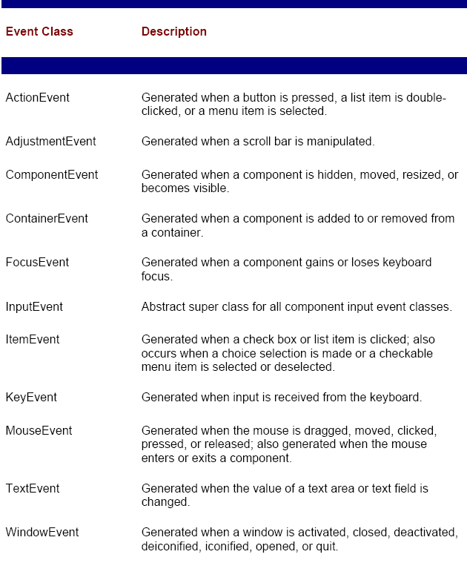

The ActionEvent Class
An ActionEvent is generated when a button is pressed, a list item is double-clicked, or a menu item is selected. The ActionEvent class defines four integer constants that can be used to identify any modifiers associated with an action event: ALT_MASK, CTRL_MASK, META_MASK, and SHIFT_MASK. In addition, there is an integer constant, ACTION_PERFORMED, which can be used to identify action events. ActionEvent has these two constructors:
ActionEvent(Object src, int type, String cmd)
ActionEvent(Object src, int type, String cmd, int modifiers)
Here, src is a reference to the object that generated this event. The type of the event is specified by type, and its command string is cmd. The argument modifiers indicates which modifier keys (ALT, CTRL, META, and/or SHIFT) were pressed when the event was generated.
You can obtain the command name for the invoking ActionEvent object by using the getActionCommand( ) method, shown here:
String getActionCommand( )
For example, when a button is pressed, an action event is generated that has a command name equal to the label on that button. The getModifiers( ) method returns a value that indicates which modifier keys (ALT, CTRL, META, and/or SHIFT) were pressed when the event was generated. Its form is shown here:
int getModifiers( )

The AdjustmentEvent Class
An AdjustmentEvent is generated by a scroll bar. There are five types of adjustment events. The AdjustmentEvent class defines integer constants that can be used to identify them. The constants and their meanings are shown here:
BLOCK_DECREMENT
The user clicked inside the scroll bar to decrease its value.
BLOCK_INCREMENT
The user clicked inside the scroll bar to increase its value.
TRACK
The slider was dragged.
UNIT_DECREMENT
The button at the end of the scroll bar was clicked to decrease its value.
UNIT_INCREMENT
The button at the end of the scroll bar was clicked to increase its value.
In addition, there is an integer constant, ADJUSTMENT_VALUE_CHANGED, indicates that a change has occurred.
AdjustmentEvent has this constructor:
AdjustmentEvent(Adjustable src, int id, int type, int data)
Here, src is a reference to the object that generated this event. The id equals ADJUSTMENT_VALUE_CHANGED. The type of the event is specified by type, and its associated data is data.
The getAdjustable( ) method returns the object that generated the event. Its form is shown here:
Adjustable getAdjustable( )
The type of the adjustment event may be obtained by the getAdjustmentType( ) method. It returns one of the constants defined by AdjustmentEvent. The general formis shown here:
int getAdjustmentType( )
The amount of the adjustment can be obtained from the getValue( ) method, shown here:
int getValue( )
For example, when a scroll bar is manipulated, this method returns the value represented by that change.

The ComponentEvent Class
A ComponentEvent is generated when the size, position, or visibility of a component is changed. There are four types of component events. The ComponentEvent class defines integer constants that can be used to identify them. The constants and their meanings are shown here:
COMPONENT_HIDDEN
The component was hidden.
COMPONENT_MOVED
The component was moved.
COMPONENT_RESIZED
The component was resized.
COMPONENT_SHOWN
The component became visible.
ComponentEvent has this constructor:
ComponentEvent(Component src, int type)
Here, src is a reference to the object that generated this event. The type of the event is specified by type.ComponentEvent is the superclass either directly or indirectly of ContainerEvent, FocusEvent, KeyEvent, MouseEvent, and WindowEvent. The getComponent( ) method returns the component that generated the event. It is
shown here:
Component getComponent( )

The ContainerEvent Class
A ContainerEvent is generated when a component is added to or removed from a container. There are two types of container events. The ContainerEvent class defines int constants that can be used to identify them: COMPONENT_ADDED and COMPONENT_REMOVED. They indicate that a component has been added to or removed from the container. ContainerEvent is a subclass of ComponentEvent and has this constructor:
ContainerEvent(Component src, int type, Component comp)
Here, src is a reference to the container that generated this event. The type of the event is specified by type, and the component that has been added to or removed from the container is comp. You can obtain a reference to the container that generated this event by using the getContainer( ) method, shown here:
Container getContainer( )
The getChild( ) method returns a reference to the component that was added to or removed from the container. Its general form is shown here:
Component getChild( )

The FocusEvent Class
A FocusEvent is generated when a component gains or loses input focus. These events are identified by the integer constants FOCUS_GAINED and FOCUS_LOST. FocusEvent is a subclass of ComponentEvent and has these constructors:
FocusEvent(Component src, int type)
FocusEvent(Component src, int type, boolean temporaryFlag)
Here, src is a reference to the component that generated this event. The type of the event is specified by type. The argument temporaryFlag is set to true if the focus event is temporary. Otherwise, it is set to false. (A temporary focus event occurs as a result of another user interface operation. For example, assume that the focus is in a text field. If the user moves the mouse to adjust a scroll bar, the focus is temporarily lost.) The isTemporary( ) method indicates if this focus change is temporary. Its form is shown here:
boolean isTemporary( )
The method returns true if the change is temporary. Otherwise, it returns false.

The InputEvent Class
The abstract class InputEvent is a subclass of ComponentEvent and is the superclass for component input events. Its subclasses are KeyEvent and MouseEvent. The InputEvent class defines the following eight integer constants that can be used to obtain information about any modifiers associated with this event:
ALT_MASK BUTTON2_MASK META_MASK
ALT_GRAPH_MASK
BUTTON3_MASK
SHIFT_MASK
BUTTON1_MASK
CTRL_MASK
The isAltDown( ), isAltGraphDown( ), isControlDown( ), isMetaDown( ), and isShiftDown( ) methods test if these modifiers were pressed at the time this event was generated. The forms of these methods are shown here:
boolean isAltDown( )
boolean isAltGraphDown( )
boolean isControlDown( )
boolean isMetaDown( )
boolean isShiftDown( )
The getModifiers( ) method returns a value that contains all of the modifier flags for this event. Its signature is shown here:
int getModifiers( )

The ItemEvent Class
An ItemEvent is generated when a check box or a list item is clicked or when a checkable menu item is selected or deselected. (Check boxes and list boxes are described later in this book.) There are two types of item events, which are identified by the following integer constants:
DESELECTED
The user deselected an item.
SELECTED
The user selected an item.
In addition, ItemEvent defines one integer constant, ITEM_STATE_CHANGED that signifies a change of state. ItemEvent has this constructor:
ItemEvent(ItemSelectable src, int type, Object entry, int state)
Here, src is a reference to the component that generated this event. For example, this might be a list or choice element. The type of the event is specified by type. The specific item that generated the item event is passed in entry. The current state of that item is in state.
The getItem( ) method can be used to obtain a reference to the item that generated an event. Its signature is shown here:
Object getItem( )
The getItemSelectable( ) method can be used to obtain a reference to the ItemSelectable object that generated an event. Its general form is shown here:
ItemSelectable getItemSelectable( )
Lists and choices are examples of user interface elements that implement the ItemSelectable interface. The getStateChange( ) method returns the state change (i.e., SELECTED or DESELECTED) for the event. It is shown here:
int getStateChange( )

The KeyEvent Class
A KeyEvent is generated when keyboard input occurs. There are three types of key events, which are identified by these integer constants: KEY_PRESSED, KEY_RELEASED, and KEY_TYPED. The first two events are generated when any key is pressed or released. The last event occurs only when a character is generated. Remember, not all key presses result in characters. For example, pressing the SHIFT key does not generate a character. There are many other integer constants that are defined by KeyEvent. For example,
VK_0 through VK_9 and VK_A through VK_Z define the ASCII equivalents of the numbers and letters. Here are some others:
VK_ENTER
VK_ESCAPE
VK_CANCEL
VK_UP
VK_DOWN
VK_LEFT
VK_RIGHT
VK_PAGE_DOWN
VK_PAGE_UP
VK_SHIFT
VK_ALT
VK_CONTROL
The VK constants specify virtual key codes and are independent of any modifiers, such as control, shift, or alt.
KeyEvent is a subclass of InputEvent and has these two constructors:
KeyEvent(Component src, int type, long when, int modifiers, int code)
KeyEvent(Component src, int type, long when, int modifiers, int code, char ch)
Here, src is a reference to the component that generated the event. The type of the event is specified by type. The system time at which the key was pressed is passed in when. The modifiers argument indicates which modifiers were pressed when this key event occurred. The virtual key code, such as VK_UP, VK_A, and so forth, is passed in code. The character equivalent (if one exists) is passed in ch. If no valid character exists, then ch contains CHAR_UNDEFINED. For KEY_TYPED events, code will contain VK_UNDEFINED.
The KeyEvent class defines several methods, but the most commonly used ones are getKeyChar( ), which returns the character that was entered, and getKeyCode( ), which returns the key code. Their general forms are shown here:
char getKeyChar( )
int getKeyCode( )
If no valid character is available, then getKeyChar( ) returns CHAR_UNDEFINED. When a KEY_TYPED event occurs, getKeyCode( ) returns VK_UNDEFINED.
The MouseEvent Class
There are seven types of mouse events. The MouseEvent class defines the following integer constants that can be used to identify them:
MOUSE_CLICKED
The user clicked the mouse.
MOUSE_DRAGGED The user dragged the mouse.
MOUSE_ENTERED
The mouse entered a component.
MOUSE_EXITED
The mouse exited from a component.
MOUSE_MOVED
The mouse moved.
MOUSE_PRESSED
The mouse was pressed.
MOUSE_RELEASED
The mouse was released.
MouseEvent is a subclass of InputEvent and has this constructor:
MouseEvent(Component src, int type, long when, int modifiers, int x, int y, int clicks, boolean triggersPopup)
Here, src is a reference to the component that generated the event. The type of the event is specified by type. The system time at which the mouse event occurred is passed in when. The modifiers argument indicates which modifiers were pressed when a mouse event occurred. The coordinates of the mouse are passed in x and y. The click count is passed in clicks. The triggersPopup flag indicates if this event causes a pop-up menu to appear on this platform. The most commonly used methods in this class are getX( ) and getY( ). These return the X and Y coordinates of the mouse when the event occurred. Their forms are shown here:
int getX( )
int getY( )
Alternatively, you can use the getPoint( ) method to obtain the coordinates of the mouse. It is shown here:
Point getPoint( )
It returns a Point object that contains the X, Y coordinates in its integer members: x and y.
The translatePoint( ) method changes the location of the event. Its form is shown here:
void translatePoint(int x, int y)
Here, the arguments x and y are added to the coordinates of the event. The getClickCount( ) method obtains the number of mouse clicks for this event. Its signature is shown here:
int getClickCount( )
The isPopupTrigger( ) method tests if this event causes a pop-up menu to appear on this platform. Its form is shown here:
boolean isPopupTrigger( )

The TextEvent Class
Instances of this class describe text events. These are generated by text fields and text areas when characters are entered by a user or program. TextEvent defines the integer constant TEXT_VALUE_CHANGED. The one constructor for this class is shown here:
TextEvent(Object src, int type)
Here, src is a reference to the object that generated this event. The type of the event is specified by type. The TextEvent object does not include the characters currently in the text component that generated the event. Instead, your program must use other methods associated with the text component to retrieve that information. This operation differs from other event objects discussed in this section. For this reason, no methods are discussed here for the TextEvent class. Think of a text event notification as a signal to a listener that it should retrieve information from a specific text component.

The WindowEvent Class
There are seven types of window events. The WindowEvent class defines integer constants that can be used to identify them. The constants and their meanings are shown here:
WINDOW_ACTIVATED
The window was activated.
WINDOW_CLOSED
The window has been closed.
WINDOW_CLOSING
The user requested that the window be closed.
WINDOW_DEACTIVATED
The window was deactivated.
WINDOW_DEICONIFIED
The window was deiconified.
WINDOW_ICONIFIED
The window was iconified.
WINDOW_OPENED
The window was opened.
WindowEvent is a subclass of ComponentEvent and has this constructor:
WindowEvent(Window src, int type)
Here, src is a reference to the object that generated this event. The type of the event is type. The most commonly used method in this class is getWindow( ). It returns the Window object that generated the event. Its general form is shown here:
Window getWindow( )

Sources of Events
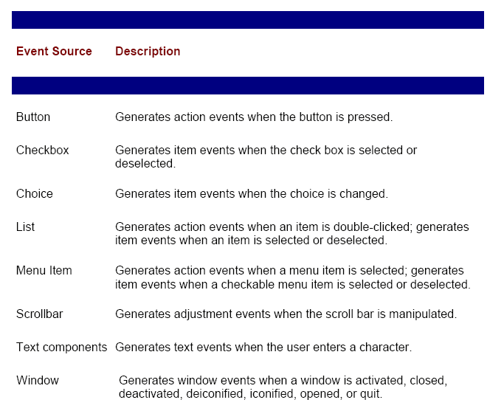
Event Listener Interfaces
As explained, the delegation event model has two parts: sources and listeners. Listeners are created by implementing one or more of the interfaces defined by the java.awt.event package. When an event occurs, the event source invokes the appropriate method defined by the listener and provides an event object as its argument.

Event Listener Interfaces

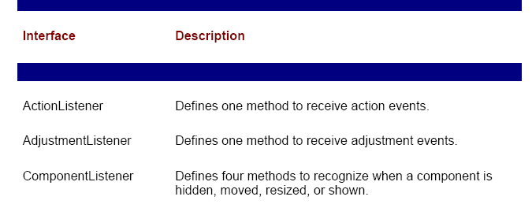
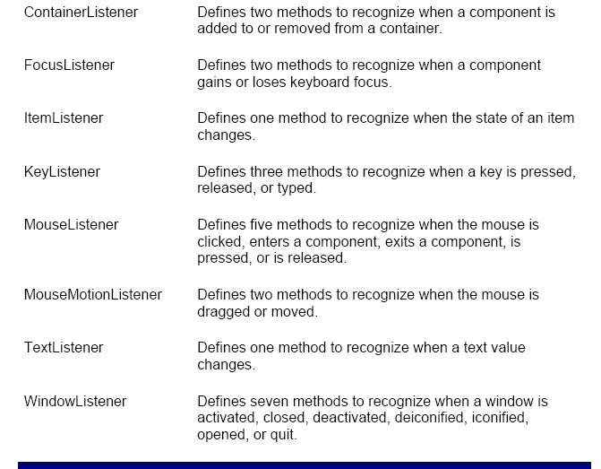

The ActionListener Interface
This interface defines the actionPerformed( ) method that is invoked when an action event occurs. Its general form is shown here:
void actionPerformed(ActionEvent ae)
The AdjustmentListener Interface
This interface defines the adjustmentValueChanged( ) method that is invoked when an adjustment event occurs. Its general form is shown here:
void adjustmentValueChanged(AdjustmentEvent ae)
The ComponentListener Interface
This interface defines four methods that are invoked when a component is resized, moved, shown, or hidden. Their general forms are shown here:
void componentResized(ComponentEvent ce)
void componentMoved(ComponentEvent ce)
void componentShown(ComponentEvent ce)
void componentHidden(ComponentEvent ce)
Note The AWT processes the resize and move events. The componentResized( ) and componentMoved( ) methods are provided for notification purposesonly.
The ContainerListener Interface
This interface contains two methods. When a component is added to a container, componentAdded( ) is invoked. When a component is removed from a container, componentRemoved( ) is invoked. Their general forms are shown here:
void componentAdded(ContainerEvent ce)
void componentRemoved(ContainerEvent ce)
The FocusListener Interface
This interface defines two methods. When a component obtains keyboard focus, focusGained( ) is invoked. When a component loses keyboard focus, focusLost( ) is called. Their general forms are shown here:
void focusGained(FocusEvent fe)
void focusLost(FocusEvent fe)
The ItemListener Interface
This interface defines the itemStateChanged( ) method that is invoked when the state of an item changes. Its general form is shown here:
void itemStateChanged(ItemEvent ie)
The KeyListener Interface
This interface defines three methods. The keyPressed( ) and keyReleased( ) methods are invoked when a key is pressed and released, respectively. The keyTyped( ) method is invoked when a character has been entered. For example, if a user presses and releases the A key, three events are generated in sequence: key pressed, typed, and released. If a user presses and releases the HOME key, two key events are generated in sequence: key pressed and released. The general forms of these methods are shown here:
void keyPressed(KeyEvent ke)
void keyReleased(KeyEvent ke)
void keyTyped(KeyEvent ke)
The MouseListener Interface
This interface defines 5 methods. If the mouse is pressed and released at the same point, mouseClicked( ) is invoked. When the mouse enters a component, the mouseEntered( ) method is called. When it leaves, mouseExited( ) is called. The mousePressed( ) and mouseReleased( ) methods are invoked when the mouse is pressed and released, respectively. The general forms of these methods are shown here:
void mouseClicked(MouseEvent me)
void mouseEntered(MouseEvent me)
void mouseExited(MouseEvent me)
void mousePressed(MouseEvent me)
void mouseReleased(MouseEvent me)
The MouseMotionListener Interface
This interface defines two methods. The mouseDragged( ) method is called multiple times as the mouse is dragged. The mouseMoved( ) method is called multiple times as the mouse is moved. Their general forms are shown here:
void mouseDragged(MouseEvent me)
void mouseMoved(MouseEvent me)

The TextListener Interface
This interface defines the textChanged( ) method that is invoked when a change occurs in a text area or text field. Its general form is shown here:
void textChanged(TextEvent te)
The WindowListener Interface
This interface defines seven methods. The windowActivated( ) and windowDeactivated( ) methods are invoked when a window is activated or deactivated, respectively. If a window is iconified, the windowIconified( ) method is called. When a window is deiconified, the windowDeiconified( ) method is called. When a window is opened or closed, the windowOpened( ) or windowClosed( ) methods are called, respectively. The windowClosing( ) method is called when a window is being closed. The general forms of these methods are
void windowActivated(WindowEvent we)
void windowClosed(WindowEvent we)
void windowClosing(WindowEvent we)
void windowDeactivated(WindowEvent we)
void windowDeiconified(WindowEvent we)
void windowIconified(WindowEvent we)
void windowOpened(WindowEvent we)

Using the Delegation Event Model
Now that you have learned the theory behind the delegation event model and have had an overview of its various components, it is time to see it in practice. Applet programming using the delegation event model is actually quite easy. Just follow these two steps:
1. Implement the appropriate interface in the listener so that it will receive the type of event desired.
2. Implement code to register and unregister (if necessary) the listener as a recipient for the event notifications.
Remember that a source may generate several types of events. Each event must be registered separately. Also, an object may register to receive several types of events, but it must implement all of the interfaces that are required to receive these events.
Handling Mouse Events
To handle mouse events, you must implement the MouseListener and the MouseMotionListener interfaces. The following applet demonstrates the process. It displays the current coordinates of the mouse in the applet's status window. Each time a button is pressed, the word "Down" is displayed at the location of the mouse pointer. Each time the button is released, the word "Up" is shown. If a button is clicked, the message "Mouse clicked" is displayed in the upper-left corner of the applet display area. As the mouse enters or exits the applet window, a message is displayed in the upper-left corner of the applet display area. When dragging the mouse, a * is shown, which tracks with the mouse pointer as it is dragged. Notice that the two variables, mouseX and mouseY, store the location of the mouse when a mouse pressed, released, or dragged event occurs. These coordinates are then used by paint( ) to display output at the point of these occurrences.
// Demonstrate the mouse event handlers.
import java.awt.*;
import java.awt.event.*;
import java.applet.*;
/*
<applet code="MouseEvents" width=300 height=100>
</applet>
*/
public class MouseEvents extends Applet
implements MouseListener, MouseMotionListener {
String msg = "";
int mouseX = 0, mouseY = 0; // coordinates of mouse
public void init() {
addMouseListener(this);
addMouseMotionListener(this);
}
// Handle mouse clicked.
public void mouseClicked(MouseEvent me) {
// save coordinates
mouseX = 0;
mouseY = 10;
msg = "Mouse clicked.";
repaint();
}
// Handle mouse entered.
public void mouseEntered(MouseEvent me) {
// save coordinates
mouseX = 0;
mouseY = 10;
msg = "Mouse entered.";
repaint();
}
// Handle mouse exited.
public void mouseExited(MouseEvent me) {
// save coordinates
mouseX = 0;
mouseY = 10;
msg = "Mouse exited.";
repaint();
}
// Handle button pressed.
public void mousePressed(MouseEvent me) {
// save coordinates
mouseX = me.getX();
mouseY = me.getY();
msg = "Down";
repaint();
}
// Handle button released.
public void mouseReleased(MouseEvent me) {
// save coordinates
mouseX = me.getX();
mouseY = me.getY();
msg = "Up";
repaint();
}
// Handle mouse dragged.
public void mouseDragged(MouseEvent me) {
// save coordinates
mouseX = me.getX();
mouseY = me.getY();
msg = "*";
showStatus("Dragging mouse at " + mouseX + ", " + mouseY);
repaint();
}
// Handle mouse moved.
public void mouseMoved(MouseEvent me) {
// show status
showStatus("Moving mouse at " + me.getX() + ", " +
me.getY());
}
// Display msg in applet window at current X,Y location.
public void paint(Graphics g) {
g.drawString(msg, mouseX, mouseY);
}
}
Sample output from this program is shown here:
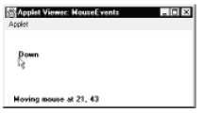
Handling Keyboard Events
To handle keyboard events, you use the same general architecture as that shown in the mouse event example in the preceding section. The difference, of course, is that you will be implementing the KeyListener interface. Before looking at an example, it is useful to review how key events are generated. When a key is pressed, a KEY_PRESSED event is generated. This results in a call to the keyPressed( ) event handler. When the key is released, a KEY_RELEASED event is generated and the keyReleased( ) handler is executed. If a character is generated by the keystroke, then a KEY_TYPED event is sent and the keyTyped( ) handler is invoked. Thus, each time the user presses a key, at least two and often three events are generated. If all you care about are actual characters, then you can ignore the information passed by the key press and release events. However, if your program needs to handle special keys, such as the arrow or function keys, then it must watch for them through the keyPressed( ) handler. There is one other requirement that your program must meet before it can process keyboard events: it must request input focus. To do this, call requestFocus( ), which is defined by Component. If you don't, then your program will not receive any keyboard events. The following program demonstrates keyboard input. It echoes keystrokes to the applet window and shows the pressed/released status of each key in the status window.
// Demonstrate the key event handlers.
import java.awt.*;
import java.awt.event.*;
import java.applet.*;
/*
<applet code="SimpleKey" width=300 height=100>
</applet>
*/
public class SimpleKey extends Applet
implements KeyListener {
String msg = "";
int X = 10, Y = 20; // output coordinates
public void init() {
addKeyListener(this);
requestFocus(); // request input focus
}
public void keyPressed(KeyEvent ke) {
showStatus("Key Down");
}
public void keyReleased(KeyEvent ke) {
showStatus("Key Up");
}
public void keyTyped(KeyEvent ke) {
msg += ke.getKeyChar();
repaint();
}
// Display keystrokes.
public void paint(Graphics g) {
g.drawString(msg, X, Y);
}
}
Sample output is shown here:
If you want to handle the special keys, such as the arrow or function keys, you need to
respond to them within the keyPressed( ) handler. They are not available through
keyTyped( ). To identify the keys, you use their virtual key codes. For example, the next
applet outputs the name of a few of the special keys:
// Demonstrate some virtual key codes.
import java.awt.*;
import java.awt.event.*;
import java.applet.*;
/*
<applet code="KeyEvents" width=300 height=100>
</applet>
*/
public class KeyEvents extends Applet
implements KeyListener {
String msg = "";
int X = 10, Y = 20; // output coordinates
public void init() {
addKeyListener(this);
requestFocus(); // request input focus
}
public void keyPressed(KeyEvent ke) {
showStatus("Key Down");
int key = ke.getKeyCode();
switch(key) {
case KeyEvent.VK_F1:
msg += "<F1>";
break;
case KeyEvent.VK_F2:
msg += "<F2>";
break;
case KeyEvent.VK_F3:
msg += "<F3>";
break;
case KeyEvent.VK_PAGE_DOWN:
msg += "<PgDn>";
break;
case KeyEvent.VK_PAGE_UP:
msg += "<PgUp>";
break;
case KeyEvent.VK_LEFT:
msg += "<Left Arrow>";
break;
case KeyEvent.VK_RIGHT:
msg += "<Right Arrow>";
break;
}
repaint();
}
public void keyReleased(KeyEvent ke) {
showStatus("Key Up");
}
public void keyTyped(KeyEvent ke) {
msg += ke.getKeyChar();
repaint();
}
// Display keystrokes.
public void paint(Graphics g) {
g.drawString(msg, X, Y);
}
}

Adapter Classes
Java provides a special feature, called an adapter class, that can simplify the creation of event handlers in certain situations. An adapter class provides an empty implementation of all methods in an event listener interface. Adapter classes are useful when you want to receive and process only some of the events that are handled by a particular event
listener interface. You can define a new class to act as an event listener by extending one of the adapter classes and implementing only those events in which you are interested.
For example, the MouseMotionAdapter class has two methods, mouseDragged( ) and mouseMoved( ). The signatures of these empty methods are exactly as defined in the MouseMotionListener interface. If you were interested in only mouse drag events, then you could simply extend MouseMotionAdapter and implement mouseDragged( ). The empty implementation of mouseMoved( ) would handle the mouse motion events for you.

Following table lists the different adapter classes in java.awt.event and notes the interface that each implements.
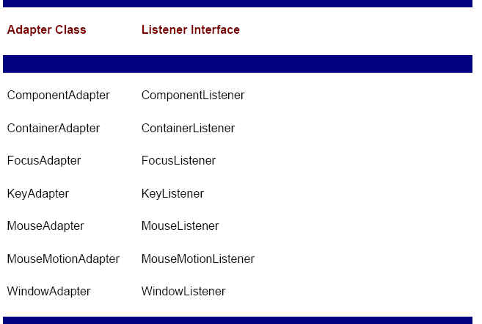

Example:
The following example demonstrates an adapter. It displays a message in the status bar of an applet viewer or browser when the mouse is clicked or dragged. However, all other mouse events are silently ignored. The program has three classes. AdapterDemo extends Applet. Its init( ) method creates an instance of MyMouseAdapter and registers that object to receive notifications of mouse events. It also creates an instance of MyMouseMotionAdapter and registers that object to receive notifications of mouse motion events. Both of the constructors take a reference to the applet as an argument. MyMouseAdapter implements the mouseClicked( ) method. The other mouse events are silently ignored by code inherited from the MouseAdapter class. MyMouseMotionAdapter implements the mouseDragged( ) method. The other mouse motion event is silently ignored by code inherited from the MouseMotionAdapter class. Note that both of our event listener classes save a reference to the applet. This information is provided as an argument to their constructors and is used later to invoke the showStatus( ) method.
// Demonstrate an adapter.
import java.awt.*;
import java.awt.event.*;
import java.applet.*;
/*
<applet code="AdapterDemo" width=300 height=100>
</applet>
*/
public class AdapterDemo extends Applet {
public void init() {
addMouseListener(new MyMouseAdapter(this));
addMouseMotionListener(new MyMouseMotionAdapter(this));
}
}
class MyMouseAdapter extends MouseAdapter {
AdapterDemo adapterDemo;
public MyMouseAdapter(AdapterDemo adapterDemo) {
this.adapterDemo = adapterDemo;
}
// Handle mouse clicked.
public void mouseClicked(MouseEvent me) {
adapterDemo.showStatus("Mouse clicked");
}
}
class MyMouseMotionAdapter extends MouseMotionAdapter {
AdapterDemo adapterDemo;
public MyMouseMotionAdapter(AdapterDemo adapterDemo) {
this.adapterDemo = adapterDemo;
}
// Handle mouse dragged.
public void mouseDragged(MouseEvent me) {
adapterDemo.showStatus("Mouse dragged");
}
}
As you can see by looking at the program, not having to implement all of the methods defined by the MouseMotionListener and MouseListener interfaces saves you a considerable amount of effort and prevents your code from becoming cluttered with empty methods. As an exercise, you might want to try rewriting one of the keyboard input examples shown earlier so that it uses a KeyAdapter.

Inner Classes
Inner class is a class defined within other class, or even within an expression. This section illustrates how inner classes can be used to simplify the code when using event adapter classes. To understand the benefit provided by inner classes, consider the applet shown in the following listing. It does not use an inner class. Its goal is to display the string "Mouse Pressed" in the status bar of the applet viewer or browser when the mouse is pressed. There are two top-level classes in this program. MousePressedDemo extends Applet, and MyMouseAdapter extends MouseAdapter. The init( ) method of MousePressedDemo instantiates MyMouseAdapter and provides this object as an argument to the addMouseListener( ) method. Notice that a reference to the applet is supplied as an argument to the MyMouseAdapter constructor. This reference is stored in an instance variable for later use by the mousePressed( ) method. When the mouse is pressed, it invokes the showStatus( ) method of the applet through the stored applet reference. In other words, showStatus( ) is invoked relative to the applet reference stored by MyMouseAdapter.
// This applet does NOT use an inner class.
import java.applet.*;
import java.awt.event.*;
/*
<applet code="MousePressedDemo" width=200 height=100>
</applet>
*/
public class MousePressedDemo extends Applet {
public void init() {
addMouseListener(new MyMouseAdapter(this));
}
}
class MyMouseAdapter extends MouseAdapter {
MousePressedDemo mousePressedDemo;
public MyMouseAdapter(MousePressedDemo mousePressedDemo) {
this.mousePressedDemo = mousePressedDemo;
}
public void mousePressed(MouseEvent me) {
mousePressedDemo.showStatus("Mouse Pressed.");
}
}

The following listing shows how the preceding program can be improved by using an inner class. Here, InnerClassDemo is a top-level class that extends Applet. MyMouseAdapter is an inner class that extends MouseAdapter. Because MyMouseAdapter is defined within the scope of InnerClassDemo, it has access to all of the variables and methods within the scope of that class. Therefore, the mousePressed( ) method can call the showStatus( ) method directly. It no longer needs to do this via a stored reference to the applet. Thus, it is no longer necessary to pass MyMouseAdapter( ) a reference to the invoking object.
// Inner class demo.
import java.applet.*;
import java.awt.event.*;
/*
<applet code="InnerClassDemo" width=200 height=100>
</applet>
*/
public class InnerClassDemo extends Applet {
public void init() {
addMouseListener(new MyMouseAdapter());
}
class MyMouseAdapter extends MouseAdapter {
public void mousePressed(MouseEvent me) {
showStatus("Mouse Pressed");
}
}
}

Anonymous Inner Classes
An anonymous inner class is one that is not assigned a name. This section illustrates how an anonymous inner class can facilitate the writing of event handlers. Consider the applet shown in the following listing. As before, its goal is to display the string "Mouse Pressed" in the status bar of the applet viewer or browser when the mouse is pressed.
// Anonymous inner class demo.
import java.applet.*;
import java.awt.event.*;
/*
<applet code="AnonymousInnerClassDemo" width=200 height=100>
</applet>
*/
public class AnonymousInnerClassDemo extends Applet {
public void init( ) {
addMouseListener ( new MouseAdapter( ) {
public void mousePressed(MouseEvent me) {
showStatus("Mouse Pressed");
}
});
}
}
There is one top-level class in this program: AnonymousInnerClassDemo. The init( ) method calls the addMouseListener( ) method. Its argument is an expression that defines and instantiates an anonymous inner class. Let's analyze this expression carefully. The syntax new MouseAdapter( ) { ... } indicates to the compiler that the code between the braces defines an anonymous inner class. Furthermore, that class extends MouseAdapter. This new class is not named, but it is automatically instantiated when this expression is executed. Because this anonymous inner class is defined within the scope of AnonymousInnerClassDemo, it has access to all of the variables and methods within the scope of that class. Therefore, it can call the showStatus( ) method directly. As just illustrated, both named and anonymous inner classes solve some annoying problems in a simple yet effective way. They also allow you to create more efficient code.

